Who am I?

**Reading Rockets**

Every half term we will put how many children are Rocket Readers.

To be a Rocket Reader, children must read at home at least 3 times a week and it must be recorded in their home learning journals.

Class teachers check this every week.

Welcome to Reception at Oasis Academy Don Valley parent talk - TBC

Monthly meet – the expectations of iPads in reception and what we will use them for throughout the year – 28th September 2022

Parent event – in the academy – Friday 30th September

‘Get to know Darnall’ walk – 3rd October



# During this topic, we will be exploring our houses and homes around the world, as well as understanding where we are in our community. We will be looking at all the different activities available in class, as well as the Academy values. We will be learning about our habitudes. Our main key texts for the first half term are Three Little Pigs, This is our World: From Alaska to the Amazon – Meet 20 Children Just Like You, and Rama and Sita. We will begin to learn about lenses in our literacy lessons and using them to help us understand our stories.

# In Maths, we will be learning through our daily Maths Meetings, focusing on the routine, and using full sentences. We will be using Number blocks to understand quantifying numbers, focusing on 1, 2 and 3.

# Class Ahlberg

# Autumn Term 1 - 2022

In the future, newsletters will be placed onto TEAMS on the children’s iPads. This will be explained during the parent talk.

# Help at home by….

* Reading 3 times a week and recording in their reading journal.
* Explore the curious questions on the Knowledge Organiser.
* Help your child to complete at least three tasks from the homework menu.
* Access Purple mash and explore the website using the logins in your home learning journals.

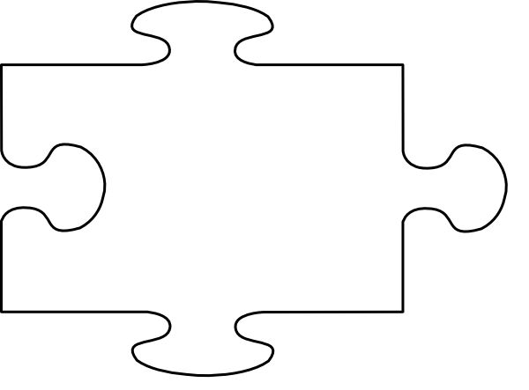



JIGSAW CORNER

This is our PSHE corner. In this jigsaw we will communicate what the children will be looking at.

This half term we will be looking at the importance of how we are feeling and using words to express our feelings.

We will also be looking at what it’s like being at school, how to be friends and use our kind hands, and the children’s rights and responsibilities.

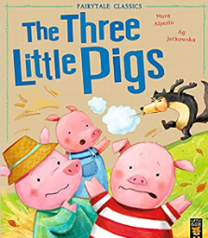

Visit our Academy Twitter and Facebook pages to find out more about what happens at Oasis Don Valley! <http://facebook.com/OasisAcademyDonValley/>

@oasisdonvalley

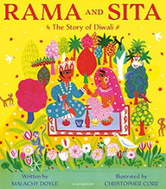 



**STAR LEARNERS**

We will confirm our PE day with you as soon as possible.

Children are not required to bring PE kits during the first half term.

**The star learner box!**

This is a very special box! Every half term, children will be chosen to be star learners – it could be one child, it could be the whole class.

[](https://www.google.co.uk/url?sa=i&rct=j&q=&esrc=s&source=images&cd=&cad=rja&uact=8&ved=2ahUKEwjTwb7H6uXfAhVMPBoKHcpeAFIQjRx6BAgBEAU&url=https://www.jigsawpshe.com/international-primary-curriculum-and-jigsaw/&psig=AOvVaw30h_95wvyE7aNGKlM2cfD3&ust=1547299658428358)