**Reading Rockets**

Last term, Class Donaldson’s highest Rocket Readers in a week was

18/29

To be a Rocket Reader, children ***must read at home at least 3 times*** a week and it must be recorded in their home learning journals.

Class teachers check this every week.

Celebrating Difference

# For this topic we will be celebrating all of our differences, whether we have a big family or a small family, our likes and dislikes and even the celebrations we do with our families, for example, Eid or Christmas. As part of this topic we will learn about celebrations, such as Bonfire Night and Remembrance Day, as well as learn all about Christmas, including the Christmas story.

# In Literacy we will be learning all about our place in the world, as well as different celebrations celebrated around the world. We will have a surprise visitor in our classes at the end of November and we will learn all about the Christmas Story.

# In Maths we will be focusing on counting, as well as using our in depth knowledge of 1-5 to begin developing a strong understanding of number bonds to 5.

# In Phonics we will continue to learn new sounds, so that by the end of the half term we should know all the sounds of the alphabet.

**Bonfire night** – 5th November

**Crucible theatre trip** – 10th November

**Remembrance Day** – 11th November

**Anti-bullying week** – 14th – 18th November

**Children in need –** 18th November

**Parent Event – TBC**

**December Monthly Meet – TBC**

**Christmas Jumper Day** – Thursday 8th December

**Primary Christmas Production -** TBC

**Pioneer Priest visit** – December





# Class Donaldson

# Autumn Term 2 - 2022

# Help at home by….

* Reading 3 times a week and recording in their reading journal.
* Explore the curious questions on the Knowledge Organiser.
* Help your child to complete at least three tasks from the homework menu.
* Access Purple mash and explore the website using the logins in your home learning journals.

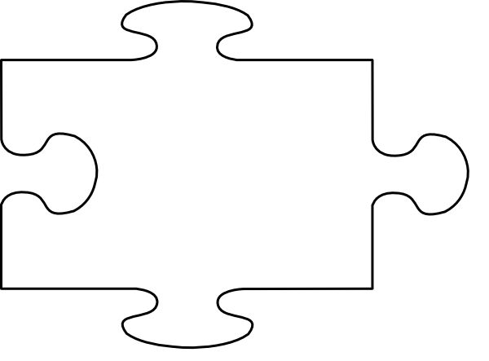

JIGSAW CORNER

This term’s Jigsaw focus is ‘Celebrating Differences’ and within this focus we will learn about what makes us special, for example being able to put on our coat, speaking another language, and how it doesn’t matter if our strengths are different to others. We will develop our friendships and what it means to be a good friend. Every Jigsaw session we will have a ‘Calm Time’ which allows us to reflect.

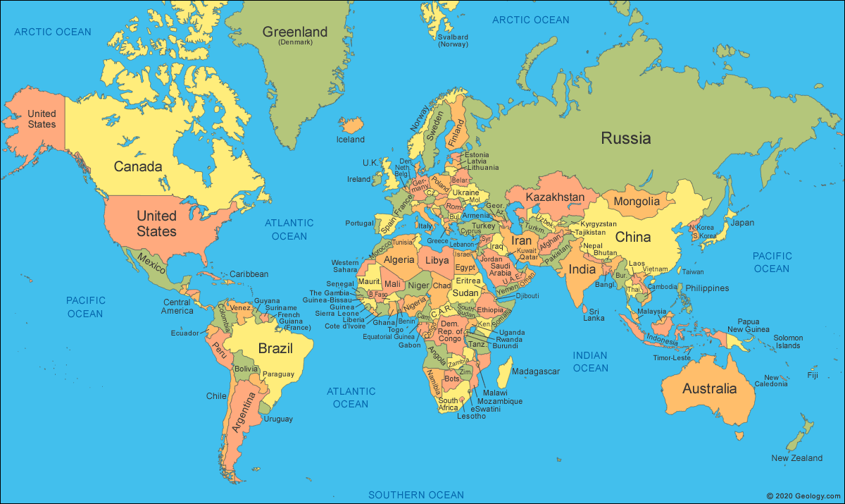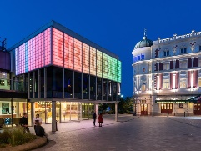

Visit our Academy Twitter and Facebook pages to find out more about what happens at Oasis Don Valley! <http://facebook.com/OasisAcademyDonValley/>  @oasisdonvalley

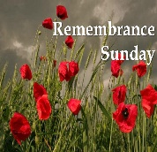



Please remember PE will be on Tuesday – we will start changing into PE bottoms this half term, so PE kits must be brought in.

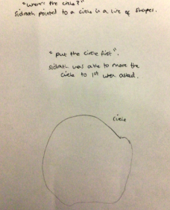**Well done to Class Donaldson’s STAR LEARNERS**

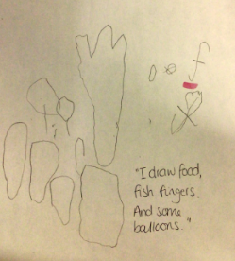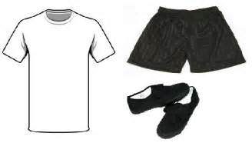

***Sidrath***, our Marvelous Mathematician

🡪

***Yousif***, our Star Writer

🡨